The Intertwining of Data, Decisions, and Reliability
D. Mandelli¹, S. Lawrence¹, T. Anselmi¹
¹Idaho National Laboratory, Idaho Falls (ID), USA

[Remove this line but leave space for DOI, which will be inserted by ANS]

ABSTRACT
The concepts of structures, systems and component (SSC) failure rate and failure probability are in principle used to model the occurrence of events (such as SSC failure) that are considered stochastic in nature. This modeling choice is imposed by the fact that we do not possess enough knowledge to model such an event (or the phenomena causing such an event) in deterministic terms through either data- or physics-based considerations. The deployment of advanced surveillance, monitoring, and prognostic and health management systems in many industries is very helpful to system engineers and plant operators monitoring the health of SSCs. These systems provide deterministic indications about SSC health and performance; consequently, the occurrence of an SSC failure event cannot be considered completely stochastic in nature. Given these premises: does it make sense to think in terms of SSC failure rate and failure probability when monitoring and surveillance activities are performed? This paper answers this question by first identifying the links between SSC health, performance, and reliability through a system engineering point of view. We then proceed by identifying the deterministic and stochastic elements of the ensemble “SSC and monitoring/surveillance” system. Based on these considerations, the SSC failure rate or failure probability is modeled by considering only the stochastic elements of the ensemble “SSC and monitoring/surveillance” system.
Keywords: reliability, risk informed, performance based

INTRODUCTION
The reliability value (expressed in terms of either probability or probability rate) associated with a structure, system, and component (SSC) is an analytical measure of the occurrence of an undesired aleatory behavior of the SSC (e.g., its failure or loss of function) [1]. Such a value is typically determined from past operational data (e.g., recorded instances of SSC failures) derived from similar SSCs operating in similar operation conditions. The same value can be refined further through Bayesian updating processes based on the observed occurrences of undesired behavior for the SSC under consideration [2]. Based on the obtained SSC reliability value, plant designers can plan for redundant SSCs to reach certain risk goals through plant probabilistic risk assessment models. Similarly, specific maintenance and surveillance operations can be periodically set to help ensure that functional and risk goals are met.
The past two decades have seen the emergence and deployment of advanced surveillance, monitoring, and prognostic and health management (S-M-PHM) computational tools in many industries for anomaly detection, diagnostic, and prognostic purposes [3,4]. These monitoring and analysis elements are very helpful to system engineers and plant operators monitoring the health of critical SSCs. Based on the health assessment of such SSCs, system engineers can perform operation and maintenance (O&M) activities designed to avoid an SSC loss of function only when needed. In this context, collected data provide indications of SSC degradation and direct proper O&M decisions. Given this “dynamic” operational setting where knowledge is accumulated by SSC PHM systems:
- What is the link between SSC performance, O&M activities, and SSC reliability?
- Does it make sense to measure SSC reliability in terms of probability or probability rate?
- If the answer is yes, which aleatory behavior should be considered as part of the reliability modeling?
This paper aims to answer these questions through a system engineering lens by looking at the functional links between data, decisions (i.e., maintenance and surveillance operations), and SSC reliability and performance. The starting point is analyzing the conceptual differences between reliability and performance associated with an SSC. A few practical examples applied to both passive and active SSCs are provided where considerations from both system engineers and probabilistic risk assessment staff will be explicitly presented. From there, the bridge between risk-informed and performance-based concepts is derived in a regulatory context (e.g., derived from U.S. Nuclear Regulatory Commission documents).

SSC OPERATIONAL CONTEXT
Generally speaking, an SSC can be defined as two connected elements (see Figure 1): its form (i.e., the physical entity and its constituent components) and the function(s) it is supporting. More precisely, the elements highlighted in gray precisely indicate that “form supports a function.” For example, when considering a centrifugal pump, the form element consists of all the components and subcomponents that make the pump (e.g., motor, stator, shaft, impeller), and the function element indicates the function of the pump (i.e., increase fluid pressure). Similarly, for passive components and subcomponents in a piping system, the form element consists of all pipes, junctions, and welds that are typically designed to perform a specific function: contain some substance (e.g., fluid, air).
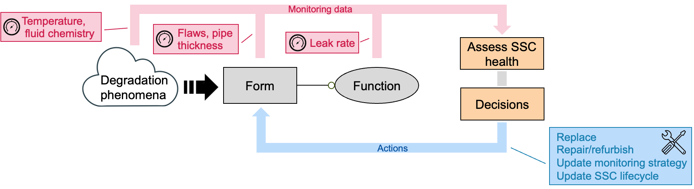
Figure 1. Representation of the relationship between SSC performance, montoring data, decisions, and degradation phenomena.
When thinking in terms of degradation phenomena (e.g., flow-accelerated corrosion, chemical erosion), it is relevant to note that they directly affect the form element (see Figure 1), which can in turn potentially impact the element’s function (e.g., reduction of pump flow rate, fluid leak out of pipe weld). The rate of degradation caused by degradation phenomena is influenced by environmental conditions (e.g., fluid chemical composition, temperature, pressure).
The monitoring data collected by S-M-PHM systems may correspond to different elements of the diagram shown in Figure 1 (see elements highlighted in red). This data quantitatively measures properties of degradation phenomena, SSC form, or SSC function. Set of decisions informed by the collected and analyzed drive a specific set of actions (see elements highlighted in blue) performed to improve the condition of the SSC form, such as:
- Maintenance activities (e.g., pump shaft replacement, pipe weld repair) to restore the form of an SSC, which consequently restores its function.
- Update monitoring strategy if the initial SSC degradation hypotheses are no longer valid (e.g., improve monitoring system performance, increase surveillance frequency). While this action does not affect the form of an SSC, it is intended to better inform decisions about O&M activities.
- Update SSC lifecycle plan (e.g., periodic SSC replacement or maintenance).
Consequently, the relationship between data and decisions becomes integrated and iterative in nature. Note that the terms SSC health and SSC performance are quantitative (i.e., deterministic) measures derived from the S-M-PHM system and they are associated with SSC form and function, respectively. SSC reliability is a probabilistic measure associated with SSC function. That being said, Figure 1 explicitly shows how the SSC reliability integral convolution of available monitoring data (including its quality and its coverage) and the decisions made based on available data.

SSC FAILURE MODELING
Using physics-based considerations, an undesired SSC event (e.g., SSC failure) can be considered an outcome resulting from the SSC microscopic structure (i.e., the capacity) not being able to withstand stress (i.e., the load) imposed by operating conditions, either normal or abnormal. While this statement has been phrased in very generic terms, it can be expanded with more details depending on the SSC operational context using mechanical, chemical, nuclear, or electrical arguments. This supports the main argument that SSC failure is the product of deterministic (i.e., physics based) phenomena. This load vs. capacity argumentation is graphically represented in Figure 2 where load and capacity are represented using probabilistic distribution functions (pdfs). When the load exceeds capacity, there is a chance for failure (see the area under the intersection of the two probability curves). Note that load and capacity could be represented as point values (rather than probabilistic distribution functions) and similar reasoning applies—when the load exceeds capacity, SSC failure is expected. In the case of point values, there is no probabilistic value describing a failure, rather the notion is failure is essentially guaranteed when the load exceeds capacity.
Following the postulation of failure phenomenon, the opposite exists; when load and capacity curves do not overlap, SSC failure cannot occur (top of Figure 2). SSC degradation over time causes the capacity curve to decay (i.e., move to the left), and when load and capacity curves overlap, SSC failure may be expected (bottom of Figure 2).
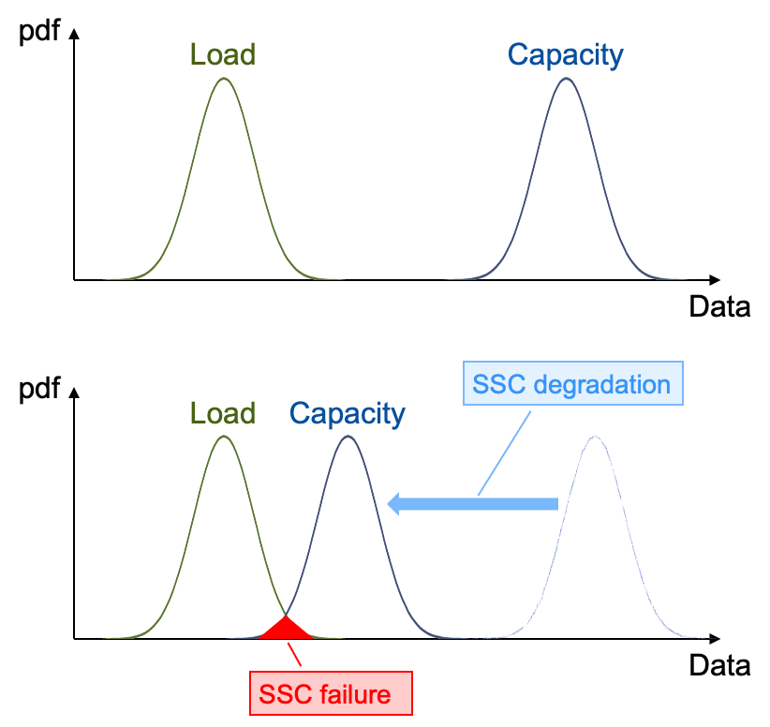
Figure 2. SSC failure represented in terms of load and capacity.

CORRELATING SSC PERFORMANCE, HEALTH, AND RELIABILITY
An initial challenge with correlating SSC performance, health, and reliability is that the performance and health monitoring of the component entails observing a physical condition, which may not directly confirm that the reliability target is being achieved. To compound the challenge, observing an unexpected component condition may not necessarily indicate a performance concern, meaning that interim criteria should be established for the owner to act without necessitating a heightened level that prompts a regulatory concern (sometimes referred to as an alert level).
To illustrate this issue, a S-M-PHM strategy may establish an observation of a material condition (which is represented in Figure 3 in terms of crack size), such as its health (identical argumentation applies if the SSC performance is examined). The expected crack size (an observable condition) can be expressed as a function of time. The bridge between observed data and SSC reliability is provided in terms of load vs. capacity (see Section 3) where deterministic and probabilistic considerations are used to assess how likely it is that the load will exceed capacity. Note that such considerations can also be framed in terms of margins, which also highlights that safety margins (e.g., imposed by codes or standards) might provide further SSC performance assurance.
From an O&M point of view, decision makers might be interested in assessing how degradation phenomena evolve with time and comparing them with past operational data. When an observed condition does not follow trends based on past operational data, such a condition is simply unexpected, and unless it is at a level of unacceptable degradation, the owner must first act to further understand the basis for being outside of the expected range and plan for recovery strategies (e.g., a reduced SSC lifetime).
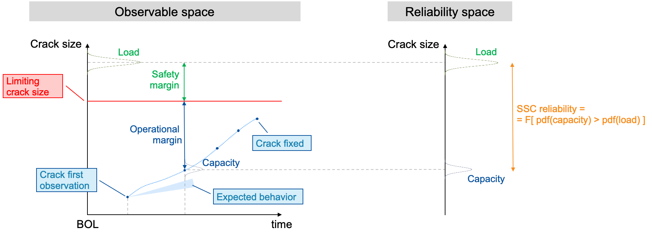
Figure 3. SSC reliability assessment based on observable data (i.e., crack size).
Figure 3 supports the fact that an observable condition may not be a safety concern if it is outside of the expected condition. This is important because a new reactor design may have limited operational experience and could have early operating data where the condition is outside of the expected region, including conditions below the expected degradation. This potential may be recognized by the plant O&M program by conducting the monitoring activity on a more frequent basis early in the plant’s operation and then less frequently as the observed condition is confirmed to be as, or better, than expected.
Note that the data provided by a monitoring system is often affected by uncertainties, which may have an impact on the actual reliability value being compared to the target reliability. In this respect, data uncertainties in the measurement system (represented as a probabilistic distribution function) can be factored into the decision process using a load vs. capacity argument.
The scenario is different when the monitoring system can detect the presence of a flaw but is not able to characterize it (e.g., its three-dimensional size). Such data cannot be represented as a data point and would not provide enough knowledge to precisely inform an O&M strategy. In such cases, the best engineering practices should be followed.
Many advanced reactors have lower overall risks, but their designs may have limited accessibility to many locations where direct examinations (e.g., ultrasonic testing or visual examinations) are necessary. Therefore, advanced reactors are expected to rely more on indirect monitoring for system parameters that lead to degradation and, to the extent practical, may include more advanced continuous monitoring techniques.
The basis for how a monitoring approach ensures adequate performance must address the ability to detect degradation. The ability to detect degradation is dependent on the attributes for monitoring. Instrumentation and sensors used for continuous monitoring require demonstrating equipment accuracy as well as demonstrating that monitoring location(s) are appropriate, and the sample size is sufficient to detect degradation and would allow the owner to determine the next action based on the identified condition.

SSC S-M-PHM RELIABILITY MODELING
From Section 4, we argue that deterministic information generated by the S-M-PHM system can provide quantitative information about SSC health and performance. Thus, does it make sense to think in terms of SSC failure rate or failure probability (i.e., which are stochastic in nature)? The transition from deterministic (i.e., physics based) to stochastic arguments of SSC failure is here described by using these extreme situations:
- No knowledge about SSC performance or health (i.e., no monitoring data). In this scenario, SSC reliability is measured probabilistically based on observed historical tested performance (e.g., the number of failures occurred within a time interval for a population of similar SSCs).
- Complete knowledge about SSC performance or health. This hypothetical scenario assumes that available monitoring data provides a continuous and complete understanding of the degradation phenomena that leads to the occurrence of an undesired event. In addition, it is also assumed that the SSC can be rapidly restored (compared to the degradation phenomena progression rate) once degradation is observed. Under these circumstances, an undesired SSC event cannot occur (i.e., SSC reliability is 1.0).
Because these are extremes, it is here recognized that an SSC subject to an S-M-PHM strategy has some monitoring data (not precise, nor complete) that shows that SSC health and performance lie between the two extreme situations listed above and has a direct impact on how to model SSC reliability. As indicated in Section 2, the combination of monitoring data, decisions, and actions implies that SSC degradation has a deterministic (also referred as performance based) aspect while still having an aleatory aspect to its performance. In fact, when degradation phenomena are observed, characterized, and tracked, physics-based considerations (through experimental and past operational data) can be used to assess their evolution and evaluate the likelihood of SSC failure based on the previously introduced load vs. capacity arguments. Based on this knowledge, appropriate proactive O&M actions are taken to avoid SSC failure.
Thus, from these considerations, SSC failure can occur if any of these conditions are satisfied:
- Missed or misinterpreted identification of SSC degradation from direct or indirect monitoring data (e.g., degradation is not detected, degradation is not appropriately categorized)
- Inability to act before event occurrence after SSC degradation has been detected.
The first condition points to the elements of the SSC S-M-PHM plan that are unknown since monitoring data might not be available continuously, it might not provide a precise assessment of SSC degradation (e.g., probability of detection). If data are collected periodically, the plan might not exhaustively cover all physical elements of the SSC and monitoring system detecting capabilities might be imprecise (as measured values might be affected by uncertainties or the monitoring system might not be able to reliably detect degradation phenomena).
The second combines physics-based considerations informed by available monitoring data with the actual SSC O&M strategy (e.g., time to take corrective action), which might be aleatory in nature. More precisely, the second condition points to the elements of the SSC S-M-PHM plan that are known (i.e., degradation phenomena have been detected and their evolution can be tracked). The presence of such degradation poses a critical element that might lead to SSC failure, which can be quantified using load vs. capacity considerations described above (i.e., deterministic in nature). In addition, the prescribed corrective actions defined in the SSC O&M plan cannot be immediate, and hence, the time to perform such actions needs to be compared with the progression rate of the degradation phenomena.
Thus, the goal of the SSC reliability modeling within an S-M-PHM context is to capture the probabilistic nature of the conditions listed above; such reliability considerations are presented in detail in Section 4.
The following presents three common SSC operational scenarios that describe the elements that affect actual SSC reliability. The common theme throughout is that SSC reliability is a measure that balances SSC performance (i.e., data) and decisions. Consider the scenarios where SSC performance is not monitored (Section 5.1), SSC is monitored through periodic surveillance inspections (Section 5.2), and SSC is subject to continuous monitoring (Section 5.3).

SSC Without S-M-PHM Programs
This first scenario considers an SSC where neither a monitoring system nor surveillance programs are used. Thus, once the undesired event occurs (e.g., SSC failure), corrective actions are performed (see Figure 4). SSC reliability is a measure of the occurrence of an undesired event, which is considered completely aleatory in nature. The rate of occurrence of the undesired event is estimated using historical or experimental failure data. In addition, Bayesian updating methods can be performed while the SSC is operating and operating data (e.g., the number of undesired event occurrences through the SSC life) are available.
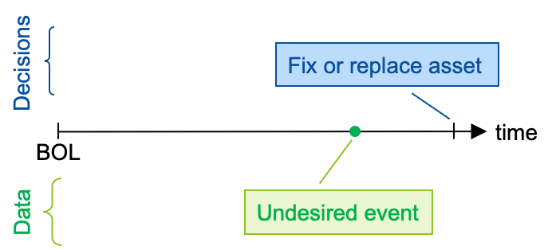
Figure 4. Temporal relations between data and decisions for an SSC where monitoring and inspection programs are not in place.
Note that the same arguments here apply to the scenario when periodic surveillance tests if the SSC performs its intended function(s). Here, data collected are Boolean in nature, either the SSC performs its function(s) or not.

SSC Under Periodic Inspections
Considering a scenario where an SSC is periodically examined to identify flaws at a fixed interval set as $∆T$, (see Figure 5). Once a flaw is detected, its progression is monitored at either the same frequency (i.e., with $∆T$ as the time interval between inspections) or at an increased frequency. Once degradation progression reaches predefined limits, corrective actions (i.e., the SSC is either fixed or replaced) are taken before the failure. As indicated in Section 5, the occurrence of such undesired events can occur if either the flaw is not detected or corrective actions are not taken in a timely manner prior to the event occurrence.
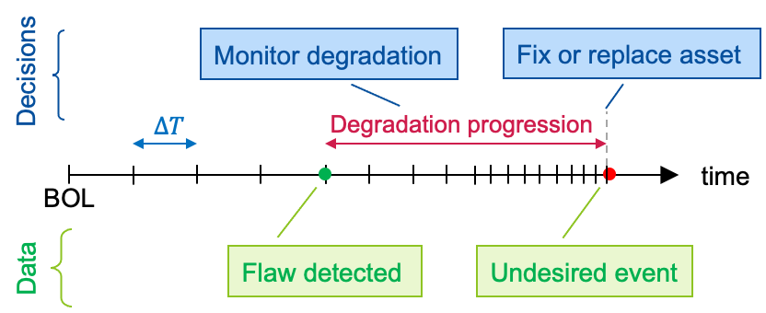
Figure 5. Temporal relations between data and decisions for an SSC under periodic inspection.
Table 1 presents the information used for modeling from a reliability perspective. Note that the set of listed variables are associated with flaw emergence, and physical phenomena behind degradation progression. Regarding the phenomena behind degradation progression, such knowledge is mostly physics based using experimental and past operational data to quantify the temporal evolution of a flaw-to-failure process. Advanced modeling techniques based on fracture mechanics are now available as well for a more accurate modeling of degradation progression over time.
Table 1. Reliability modeling parameters associated with an SSC under periodic inspection.
Symbol | Name | Notes
$$r_{flaw}$$ | Probabilistic rate of flaw occurrence | The flaw occurrence in an SSC is considered aleatory in nature
$$T_{flaw}$$ | Flaw temporal progression | Estimated time for a flaw to cause the undesired event
$$∆T$$ | Frequency of periodic inspections | Inspection frequency
$$POD$$ | Probability of flaw detection of the monitoring system | The probability of flaw detection is considered aleatory in nature and the estimated performance of detection system based on past operational experience and testing
$$T_{corr}$$ | Time required to take appropriate corrective actions | Time estimated based on past operational experience
Given the information provided in Table 1, the SSC reliability under periodic inspections can be presented as $Prob\left(event\right)$, which indicates the probability associated with the occurrence of the SSC undesired event; this term can be computed as:
$$Prob\left(event\right)=Prob\left(no_detection\right)+P\left(no_timely_reaction\right)=$$  $=f\left(r_{flaw}, T_{flaw}, POD, ∆T\right)+g(∆T, T_{corr}, T_{flaw})$ | (1)
where the $f\left(.\right)$ and $g\left(.\right)$ functions indicate the probability that the flaw is not detected (i.e., $Prob\left(no_detection\right)$) and the probability that corrective actions are not performed prior to failure of the SSC (i.e., $P\left(no_timely_reaction\right)$).
At this point, if 𝑃𝑟𝑜𝑏(𝑒𝑣𝑒𝑛𝑡) is deemed unacceptable, the SSC S-M-PHM strategy needs to be updated. Two possible courses of action can be followed: increase the inspection frequency (i.e., reduce ∆𝑇) or improve the monitoring system probability of detection ($POD$) to allow for a more precise calculation of the probability of failure. If these changes result in a probability of failure that is still unacceptable, actions may be needed for the SSC form (i.e., its physical condition), such as repair or replacement.

SSC Under Continuous Monitoring
Figure 6 presents a scenario where SSC performance is monitored continuously. Once a flaw is detected, its progression continues to be monitored until the degradation progression reaches predefined limits; at this point, corrective actions to repair or replace the SSC are taken before the failure occurs. As indicated in Section 5, such undesired events can occur if either the result of a flaw is not detected or if timely corrective actions are not taken before the event occurrence.
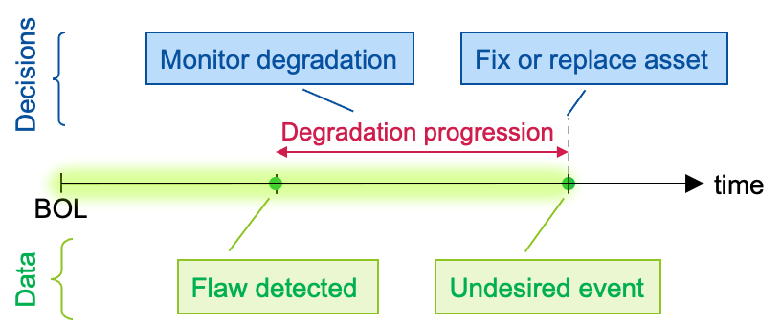
Figure 6. Temporal relations between data and decisions for an SSC under continuous monitoring.
Table 2. Reliability modeling parameters associated with an SSC under continuous monitoring.
Symbol | Name | Notes
$$r_{flaw}$$ | Probabilistic rate of flaw occurrence | The occurrence of flaw in an SSC is considered aleatory in nature
$$T_{flaw}$$ | Flaw temporal progression | The estimated time for a flaw to cause the undesired event
$$U_{monit}$$ | Unavailability of monitoring system | This term includes unavailability caused by sensors and instrumentation and control system failure
$$POD$$ | Probability of flaw detection of the monitoring system | The probability of flaw detection is considered aleatory in nature and the estimated performance of the detection system is based on past operational experience and testing
$$T_{corr}$$ | Time required to take appropriate corrective actions | Time estimated based on past operational experience
Given the information provided in Table 2, the SSC reliability under continuous monitoring is here indicated as $Prob\left(event\right)$, which indicates the probability associated with the occurrence of the SSC undesired event; this term can be computed as:
$$Prob\left(event\right)=Prob\left(no_detection\right)+P\left(no_timely_reaction\right)=$$  $=h\left(r_{flaw}, T_{flaw}, POD, U_{monit}\right)+k(U_{monit}, T_{corr}, T_{flaw})$ | (2)
where the $h\left(.\right)$ and $k\left(.\right)$ functions respectively indicate the probability that the result of a flaw is not detected (i.e., $Prob\left(no_detection\right)$), and the probability that corrective actions are not be performed before SSC failure (i.e., $P\left(no_timely_reaction\right)$).
At this point, $Prob\left(event\right)$ is compared to the target; if 𝑃𝑟𝑜𝑏(𝑒𝑣𝑒𝑛𝑡) is above the target, the SSC monitoring strategy needs to be updated. Two possible courses of action can be followed: improve monitoring performance (i.e., POD) or improve monitoring system availability to allow for a more precise calculation of the probability of failure. If these changes in the monitoring strategy result in a probability of failure that is still above the target, actions may be needed for the SSC form (i.e., its physical condition), such as repair or replacement.

SSC RELIABILITY UNDER S-M-PHM PROGRAM
At this point we can combine the observations presented in Sections 4 and 5 to measure reliability, in probabilistic terms such as failure probability, of an SSC under an S-M-PHM program. As shown in Figure 7, it consists of three elements:
- The probability of failure induced by degradation phenomena and directly observed from SSC health and performance data. In such a case, a margin-based consideration is used to assess such a probability value (see Section 3).
- The probability of failure induced by the fact that the S-M-PHM program is unable to detect the effect of the degradation phenomena (see Section 4).
- The probability of failure induced by the fact that the O&M program is unable to timely operate on the SSC to restore SSC conditions.
Note that these three elements are mutually exclusive and, hence, they can be directly summed together to determine the actual SSC reliability.
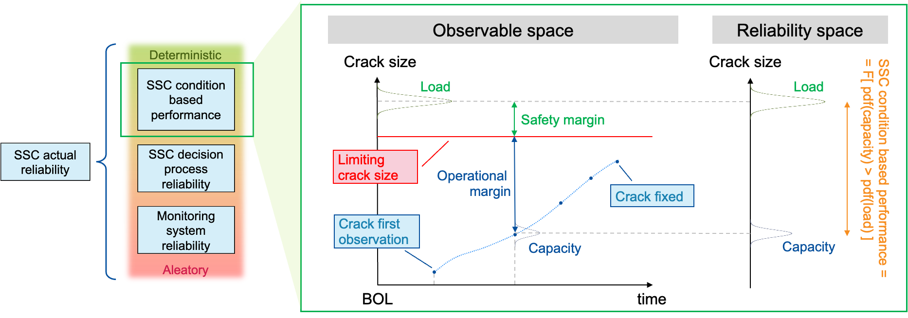
Figure 7. Decomposition of SSC reliability: SSC performance informed by available monitoring data (deterministic in nature), reliability associated with monitoring system (aleatory in nature), and reliability associated with the decision process (deterministic and aleatory in nature).

CONCLUSIONS
This paper has presented the modeling links between SSC health, performance, and reliability through a system engineering point of view. The premise is that the SSC failure rate and failure probability are designed to model an occurrence of SSC failure that is considered stochastic in nature; in other terms, we do not possess enough knowledge to model such phenomena in deterministic terms through either data- or physics-based considerations. From here we argue that S-M-PHM activities provide deterministic indications about SSC health (SSC form) and performance (SSC function); consequently, the occurrence of SSC failure is no longer completely stochastic in nature. We then provide answers to the following question: does it make sense to think in terms SSC failure rate and failure probability when S-M-PHM activities are performed? The answer to this question is crafted by first identifying the deterministic and stochastic elements of the ensemble “SSC and S-M-PHM” system. Based on these considerations, SSC failure rate or failure probability is modeled by considering only the stochastic elements of the ensemble “SSC and S-M-PHM” system. These stochastic elements are related to the fact that the S-M-PHM activities are not perfect in identifying SSC degradation and O&M activities might not be performed in time. Based on past operational data, these elements can be quantified stochastically. In addition, the third element is based purely on SSC health and performance data, which is compared to SSC operational tech-spec requirements through a margin mindset.

REFERENCES
- A. Gelman, J. Carlin, H. Stern, D. Dunson, A. Vehtari, and D. Rubin, Bayesian Data Analysis. 3rd ed., New York: Chapman and Hall/CRC, 2013.
- Hyland, A., Hoyland, A., Rausand, M. (2009). System Reliability Theory: Models and Statistical Methods. Germany: Wiley.
- NUREG/CR-6895, “Technical Review of On-Line Monitoring Techniques for Performance Assessment,” U.S. Nuclear Regulatory Commission, https://www.nrc.gov/reading-rm/doc-collections/nuregs/contract/cr6895/index.html
- ASME Section XI, Div.1, "Rules for Inspection and Testing of Components of Light-Water-Cooled Plants," American Society of Mechanical Engineers, ASME Boiler & Pressure Vessel Code, Section XI, Division 1, BPVC-XI-1 - 2021, 2021.

The assumption here is that once a flaw (or a leak) is detected, plant personnel will not deliberately lead the SSC to the undesired event.
Note that the occurrence of the SSC undesired event can be framed in terms of either probability or rate.

